Smart Potato Peeler Machine

Potato is the most widely eaten vegetable used across the globe. There are numerous recipes that make use of potatoes, the most common ones being French fries and potato chips. Well preparing any potato recipe involves a potato peeling process before the potato can be used. Peeling is a very time consuming and tiring process. So we here automate and speed up the peeling process using a fully automated potato peeling machine.
Now potato peeling is a very common process in restaurants, eateries, food processing factories and large kitchens. The compact potato peeling machine can peel off 5 kg potatoes at a time in a speedy and efficient manner.
The automatic potato peeler offers a wide variety of advantages including:
- Smart Spinning mechanism for Potato Peeling
- Ability to Peel 5kg potatoes in a few minutes
- Automatic water sprinkling for potato skin wetting
- Adjustable watering and timer settings as per requirement
- Easy to operate and use

The system makes use of a single phase ac motor to drive the peeler wheel in the vessel. The vessel is to be filled with potatoes and can hold upto 5 kg potatoes. The system also consists of a 5 litre water tank that is used to drive regular water supply into the potato peeling chamber. The water makes the skin wet allowing for easy peeling. The system allows user to modify water supply rate for water saving too as manual watering potato peeling machines waste a lot of water.

Once watering and peeler timing settings are provided the system activates the ac motor. This motor is connected to the peeler rotor through a pulley belt arrangement. Thus rotating the potato peeler wheel while constantly pouring water. The excess water drains through the sides and is then sent out through the back of the system.

Thus the machine automates potato peeling making it easy for restaurants, eateries, canteens, large kitchens to make and serve potato dishes.

Components:
- AC Motor
- Peeler Vessel
- Peeler Wheel
- Water Tank
- Water Pump
- Controller Circuitry
- Hinges
- Handle
- Pipes and Joints
- Output Tray
- Electrical & Wirings
- Mounts and Joints
- Base Frame
- Supporting Frame
- Screws and Fittings

Applications:
- Restaurants
- Eateries
- Canteens
- Mega Kitchens

Advantages:
- Smart Spinning mechanism for Potato Peeling
- Ability to Peel 5kg potatoes in a few minutes
- Automatic water sprinkling for potato skin wetting
- Adjustable watering and timer settings as per requirement
- Easy to operate and use

Disadvantages:
- Needs cleaning and maintenance
- Is not Very Portable

Block Diagram
Front View
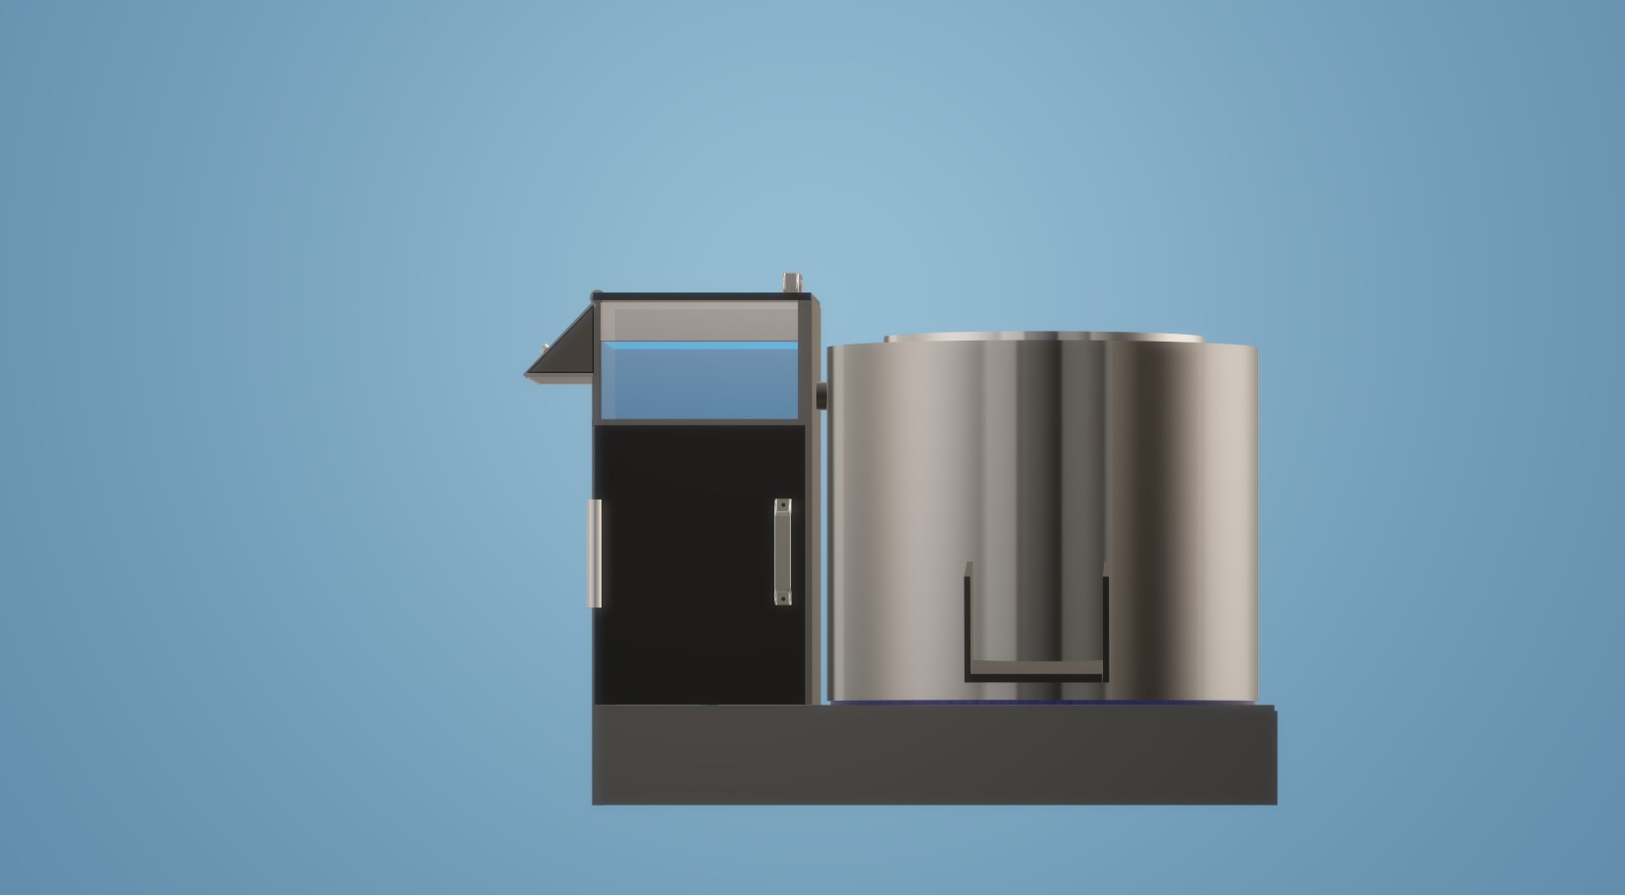
Side View
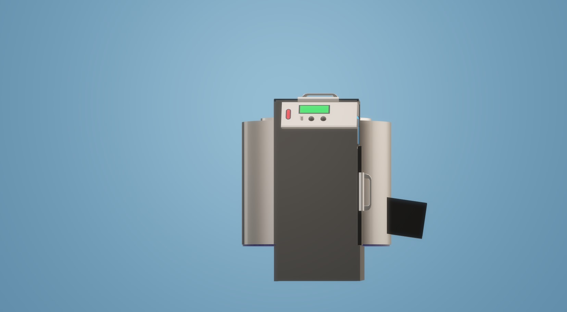

3D View
